**TREASURY RELATIVE VALUE**

Advanced Quantitative Framework

# 1. Regime Detection and Conditional Analysis

Hidden Markov Models classify market conditions into low, elevated, and high volatility regimes.

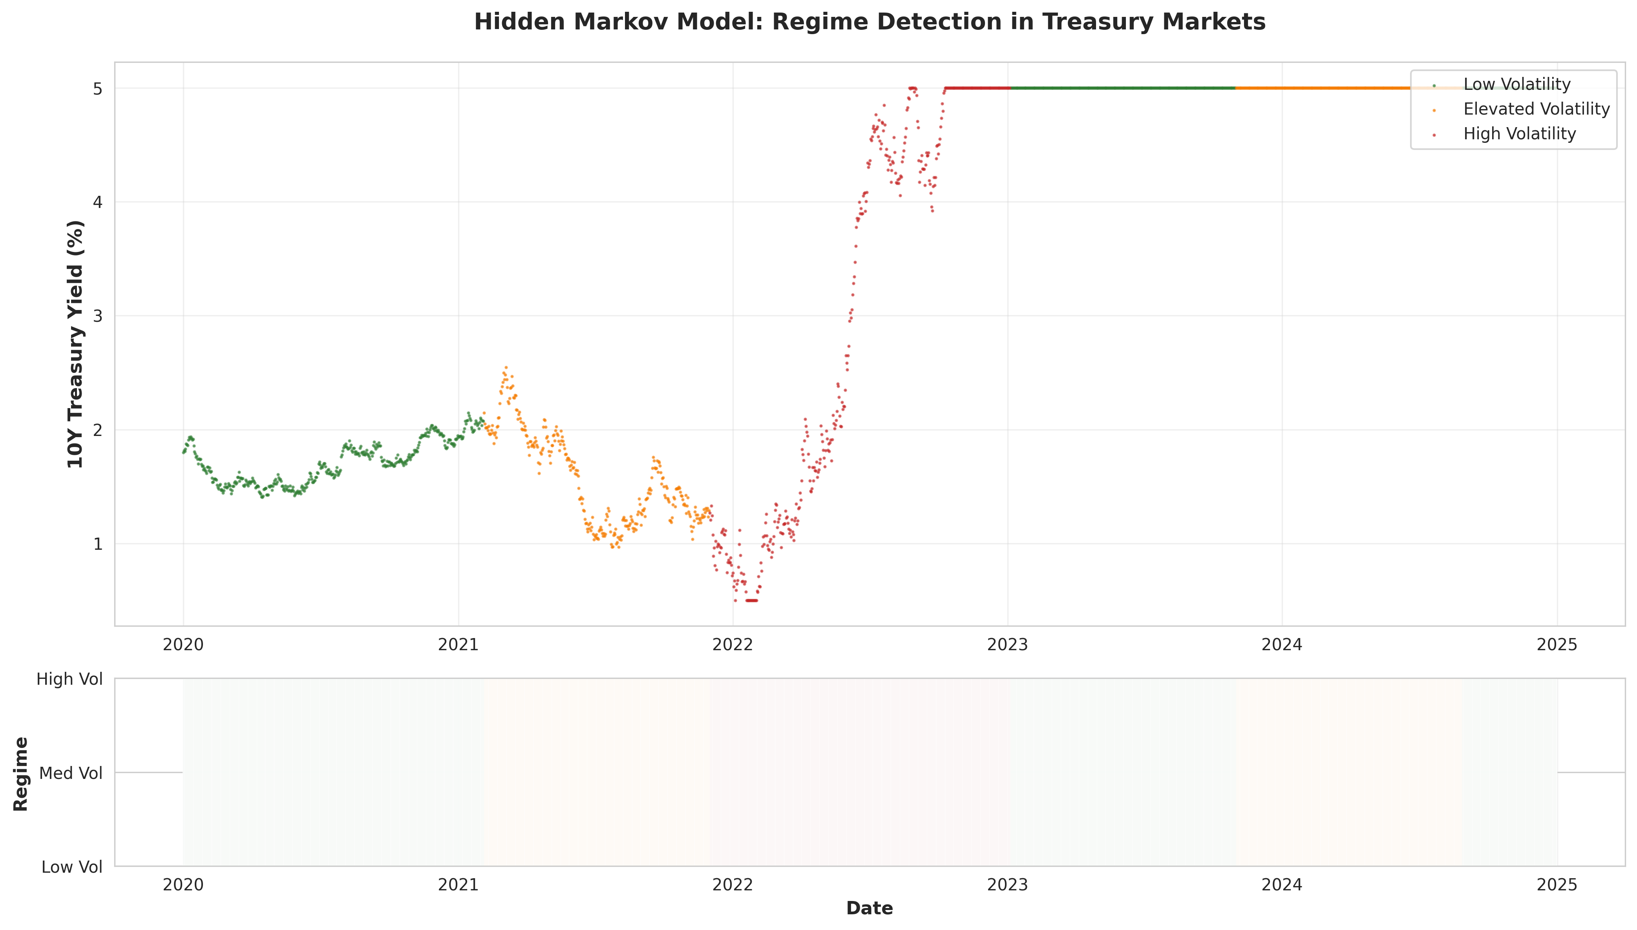

## 1.2 Regime-Conditional Z-Scores

Standard Z-scores assume stationarity. Regime-conditional approach accounts for changing distributions.

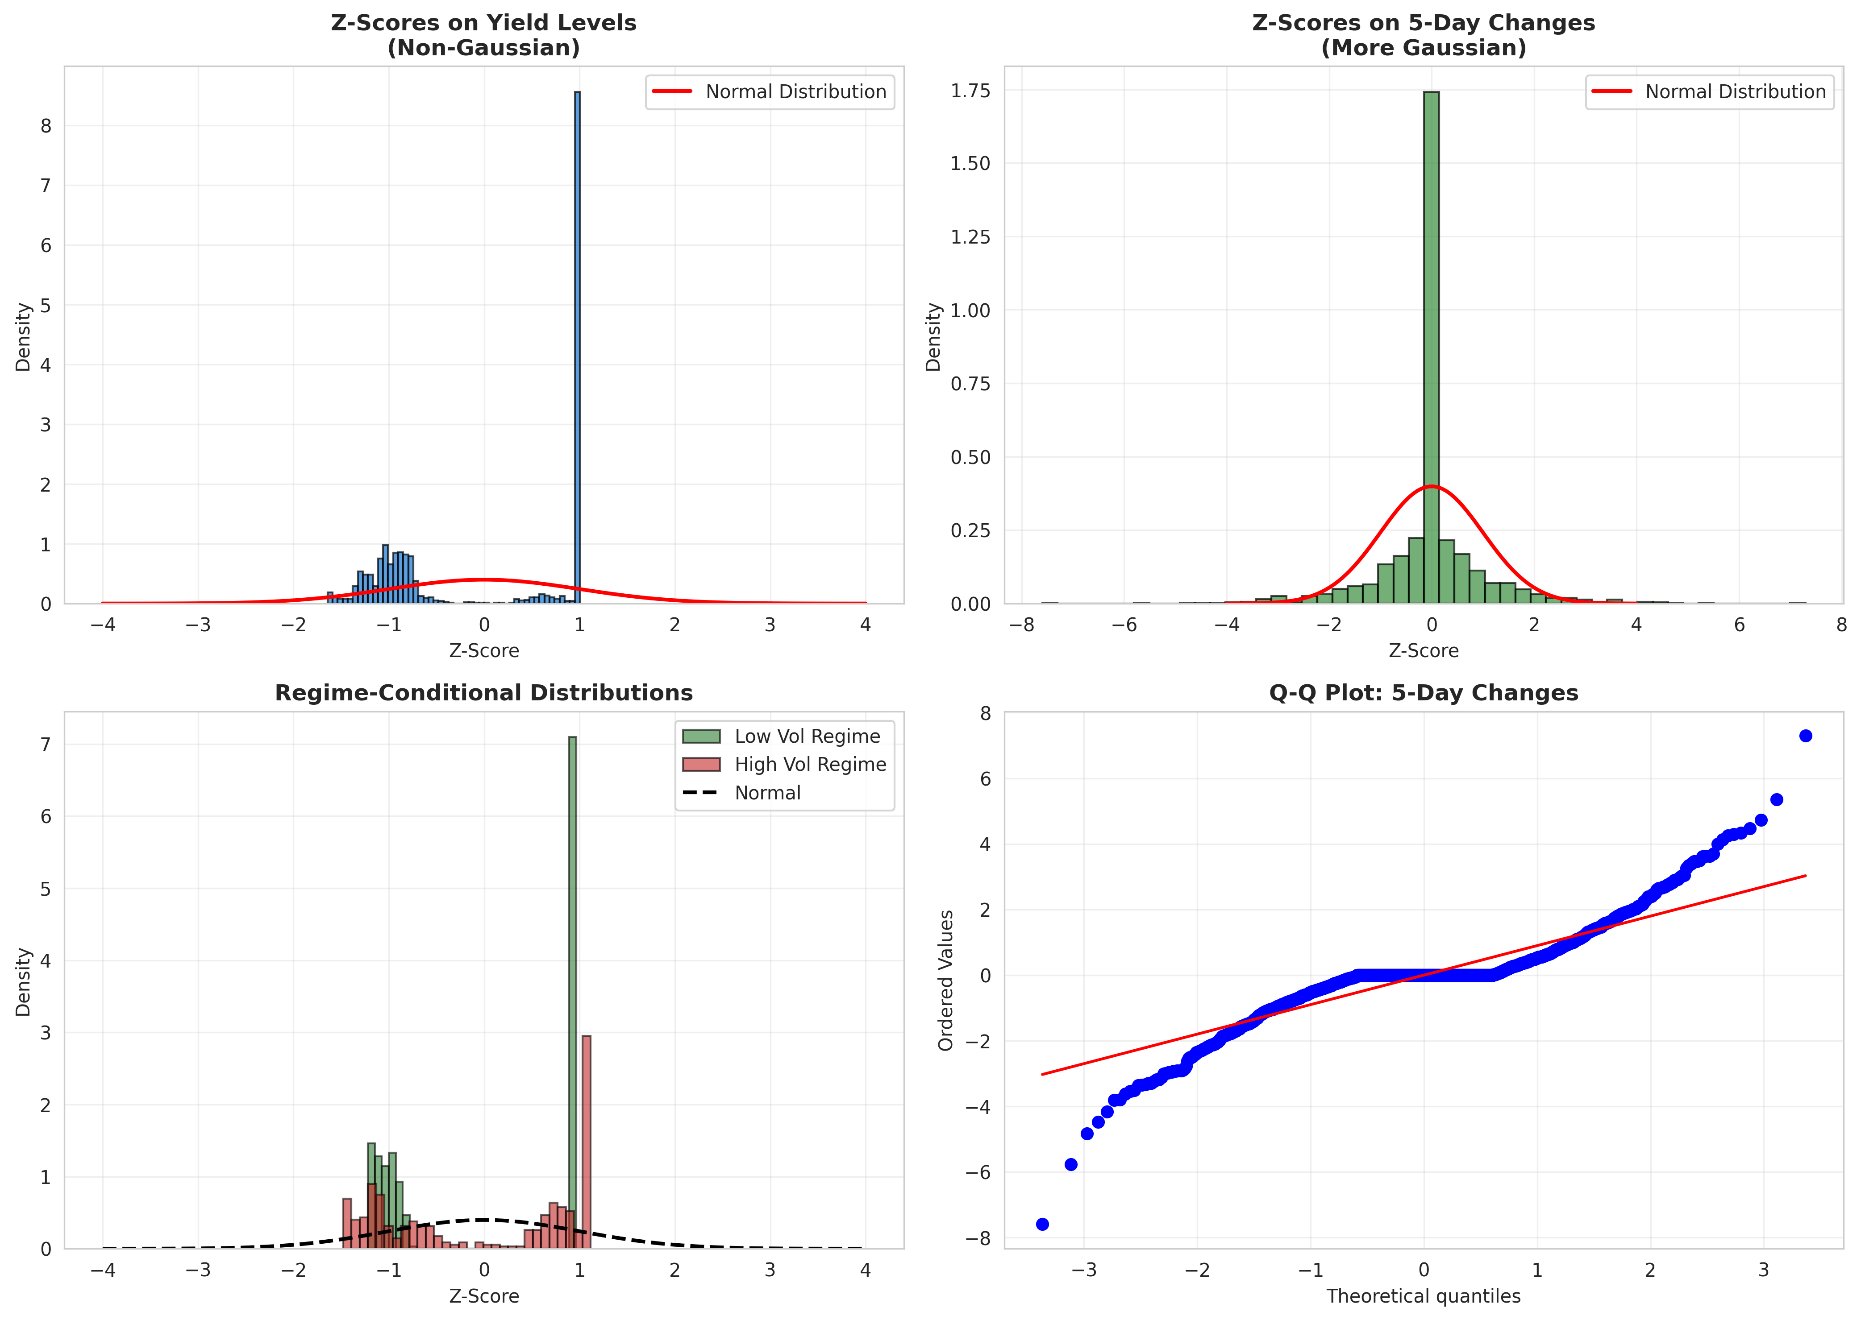

# 2. Custom Curve Fitting Methodologies

Multi-curve spline framework jointly fits Treasury, SOFR, and implied repo curves with regime-aware smoothing.

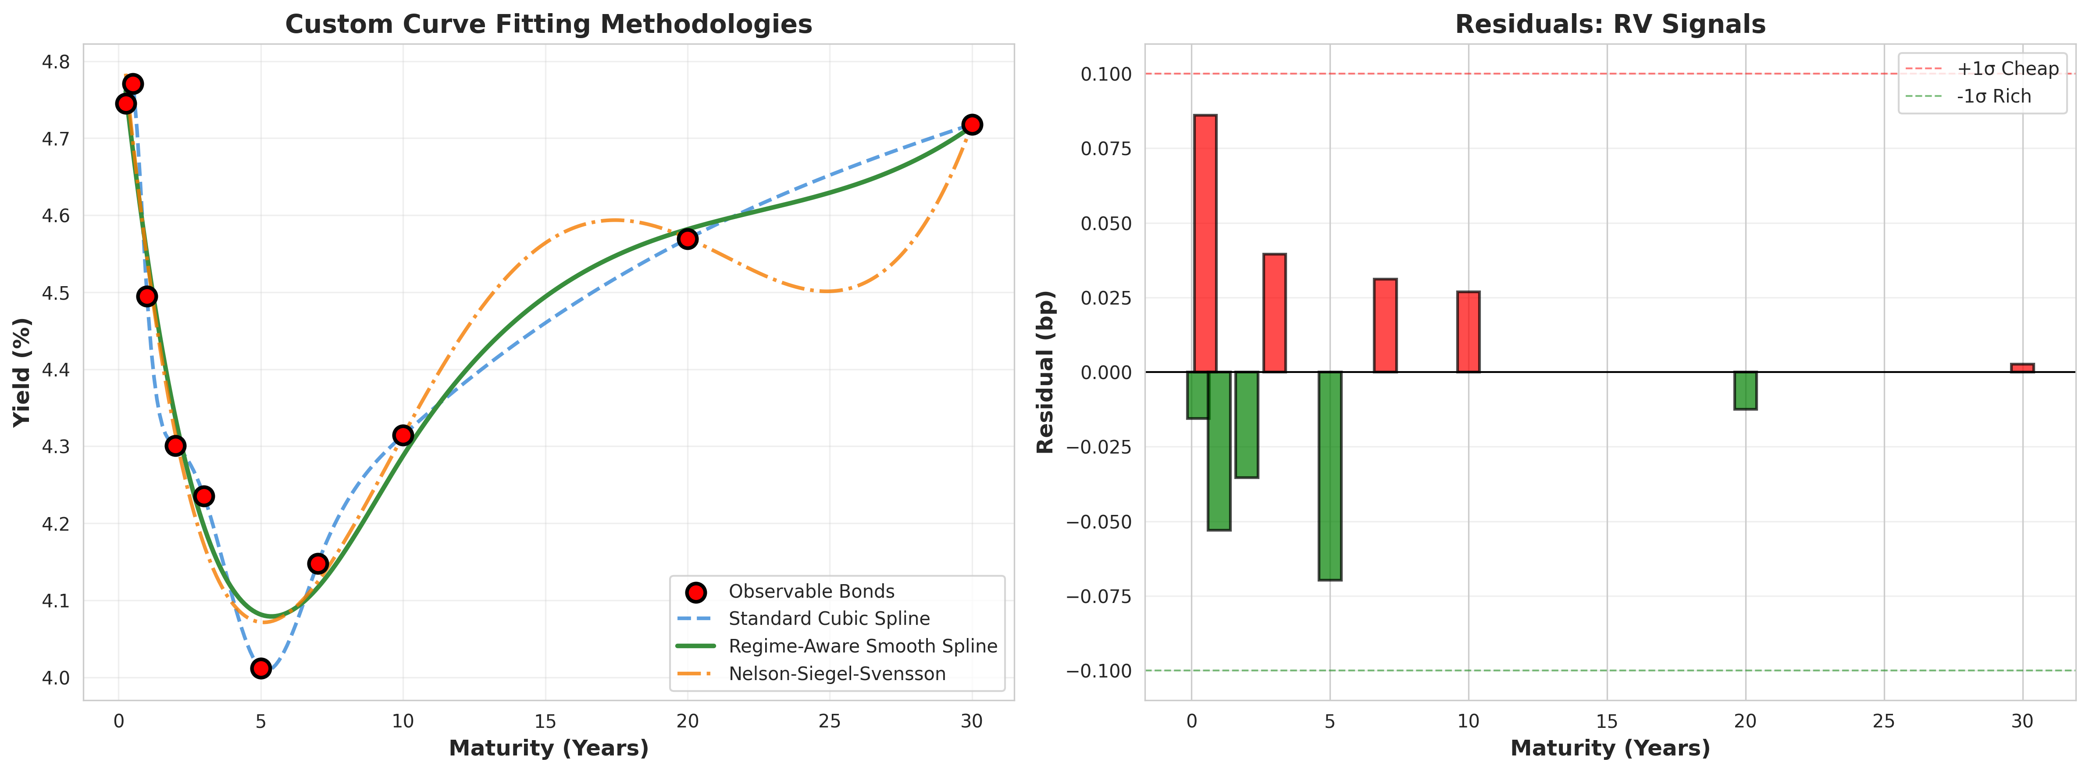

# 3. Treasury Basis Deep Dive

Comprehensive basis analysis incorporating CTD optionality, repo premia, and systematic trading signals.

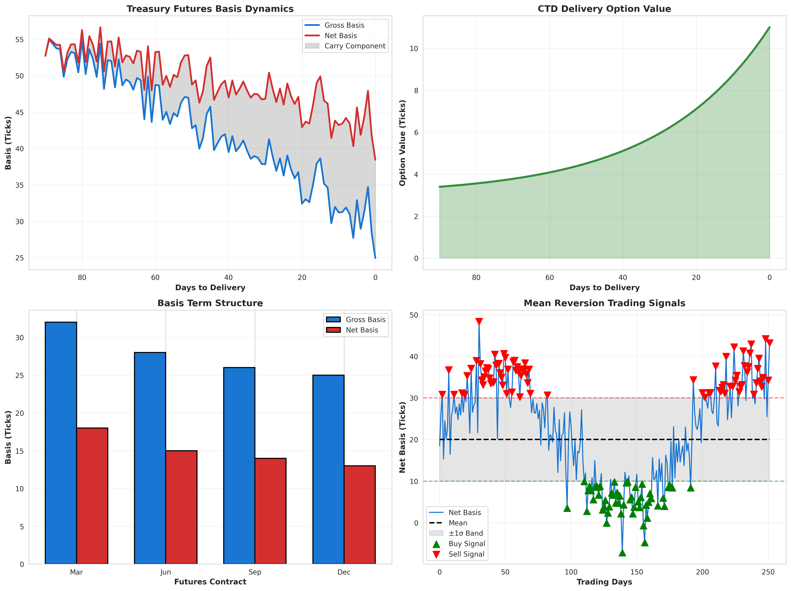

# 4. Principal Component Analysis

PCA decomposition reduces yield curve to three orthogonal factors: level, slope, and curvature.

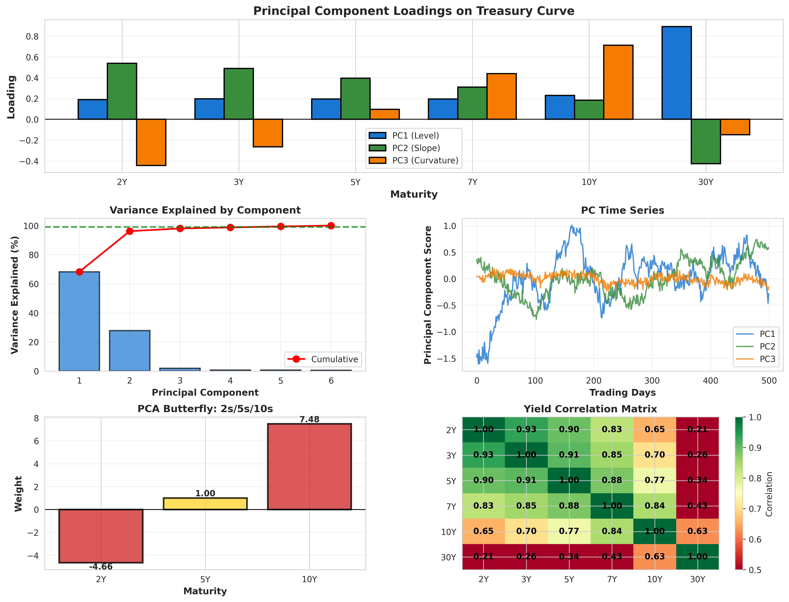

# 5. Carry & Rolldown Analysis

Vol-adjusted carry provides risk-normalized metrics for position sizing and strategy selection.

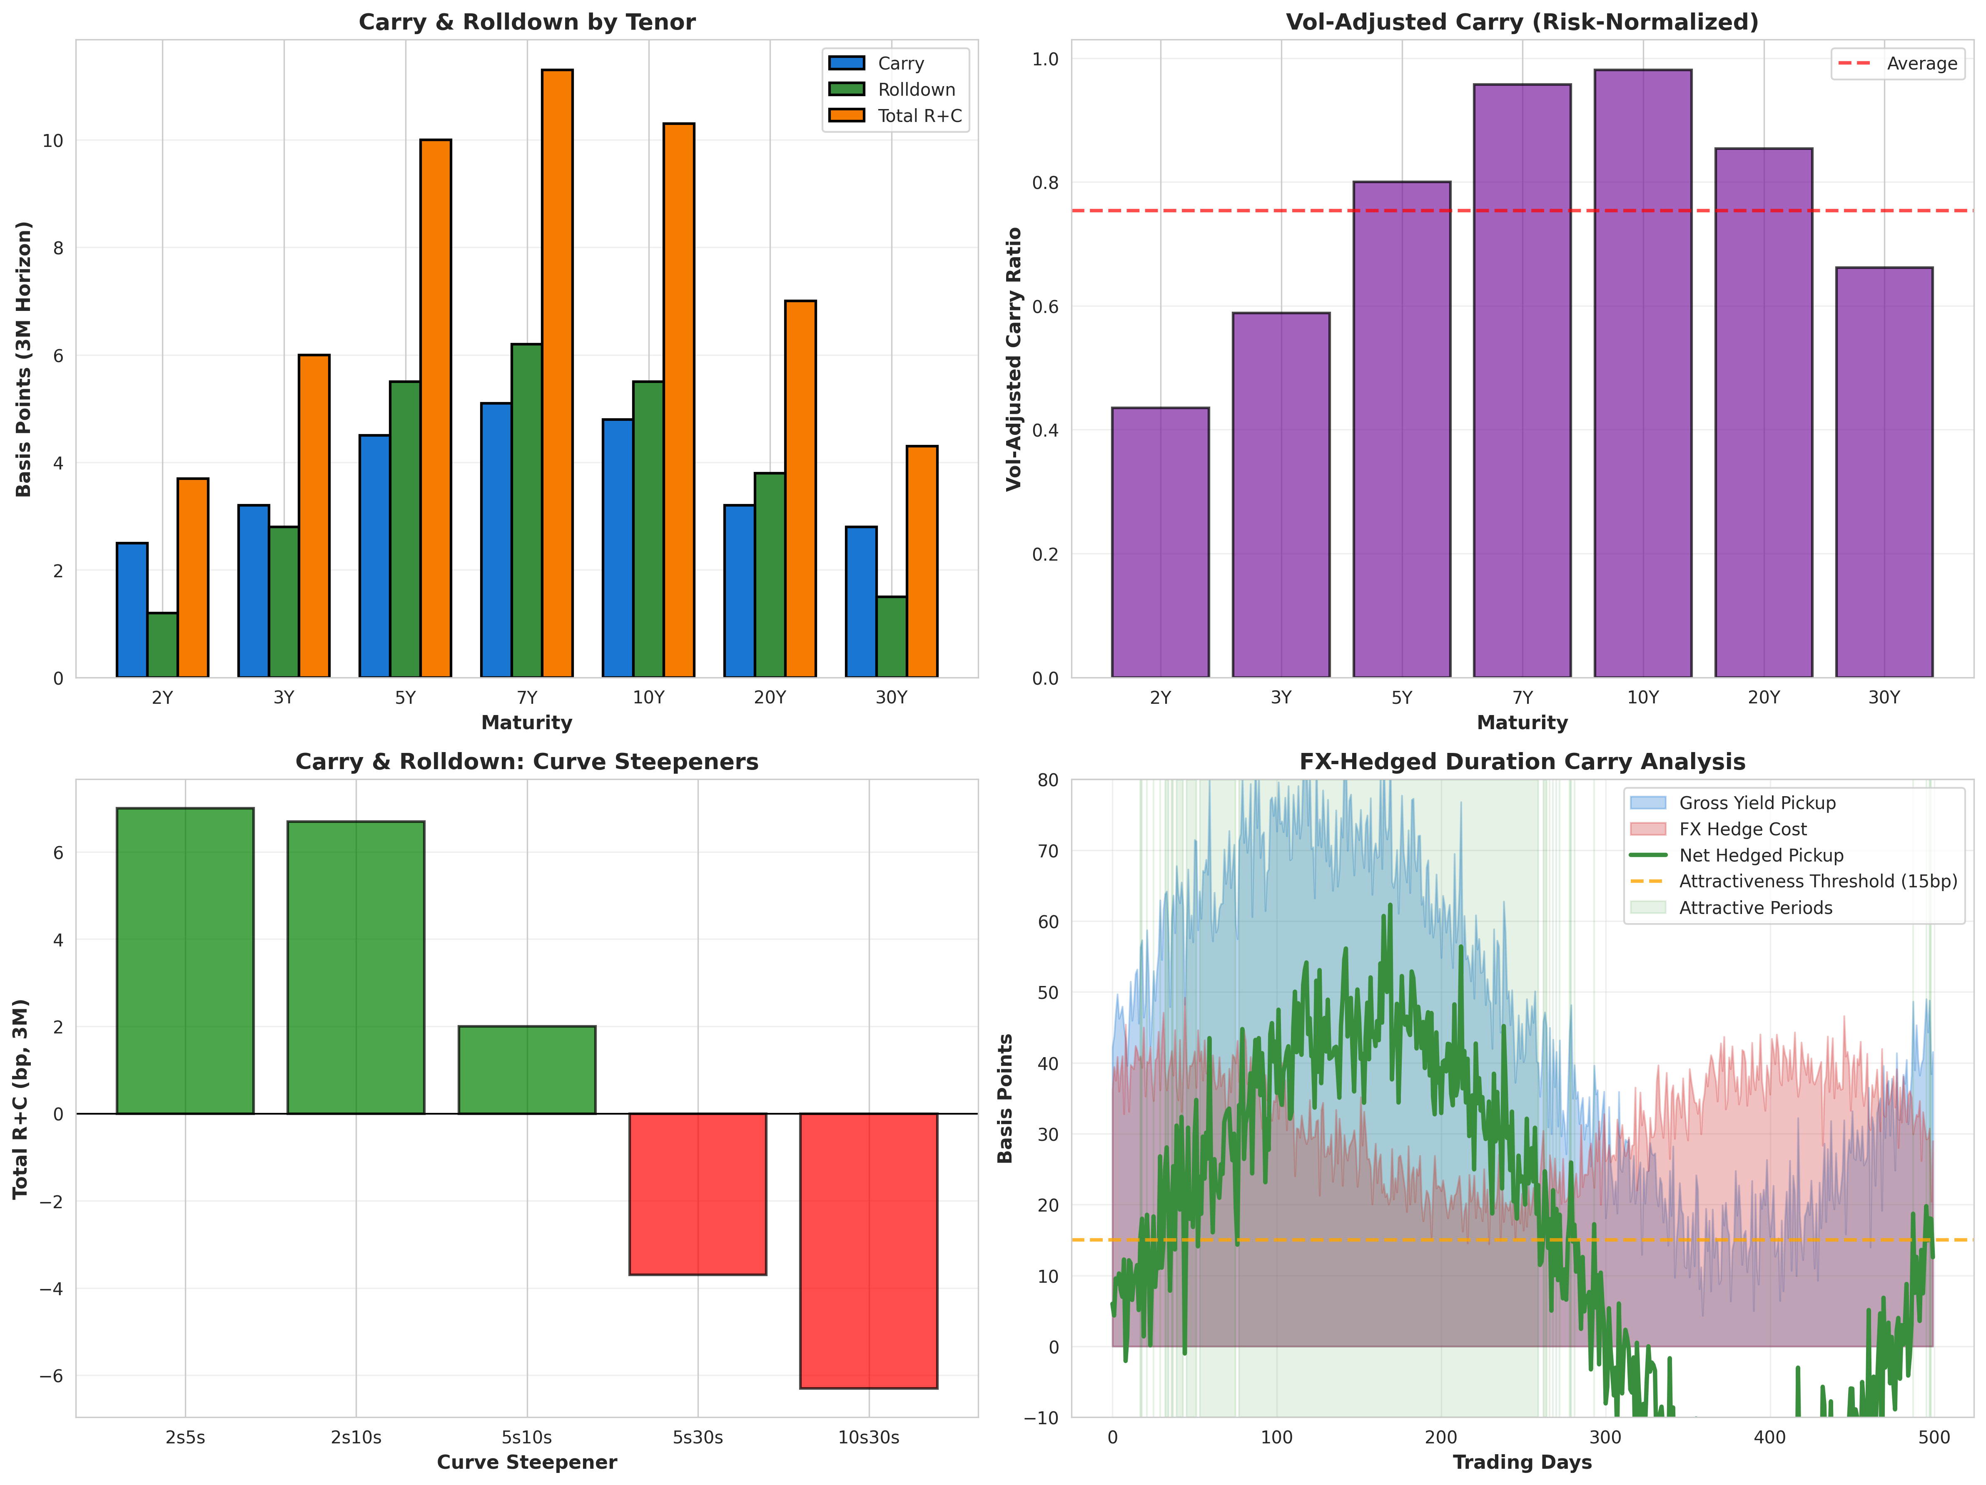

# 6. Auction Dynamics

Statistical patterns around Treasury auctions provide systematic trading opportunities.

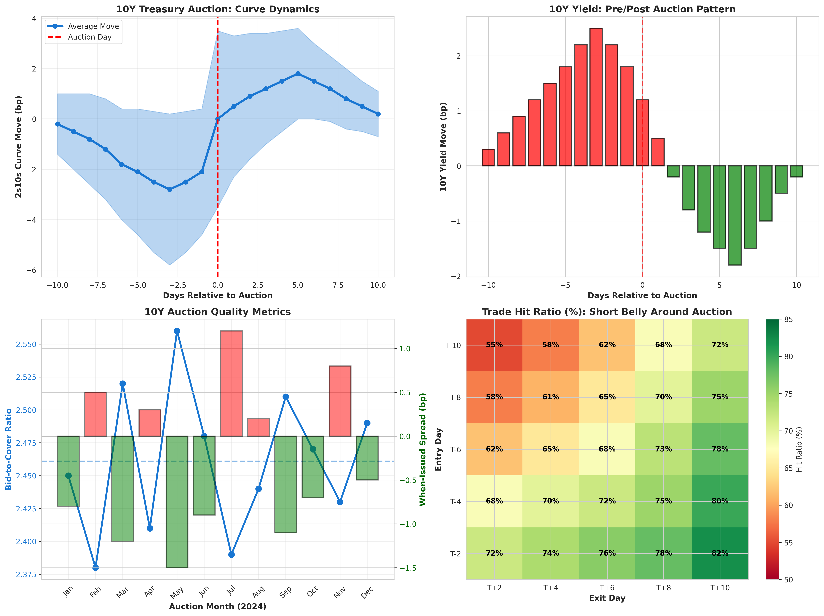

# 7. Volatility Surface Analysis

Swaption volatility surface structure drives relative value across the volatility complex.

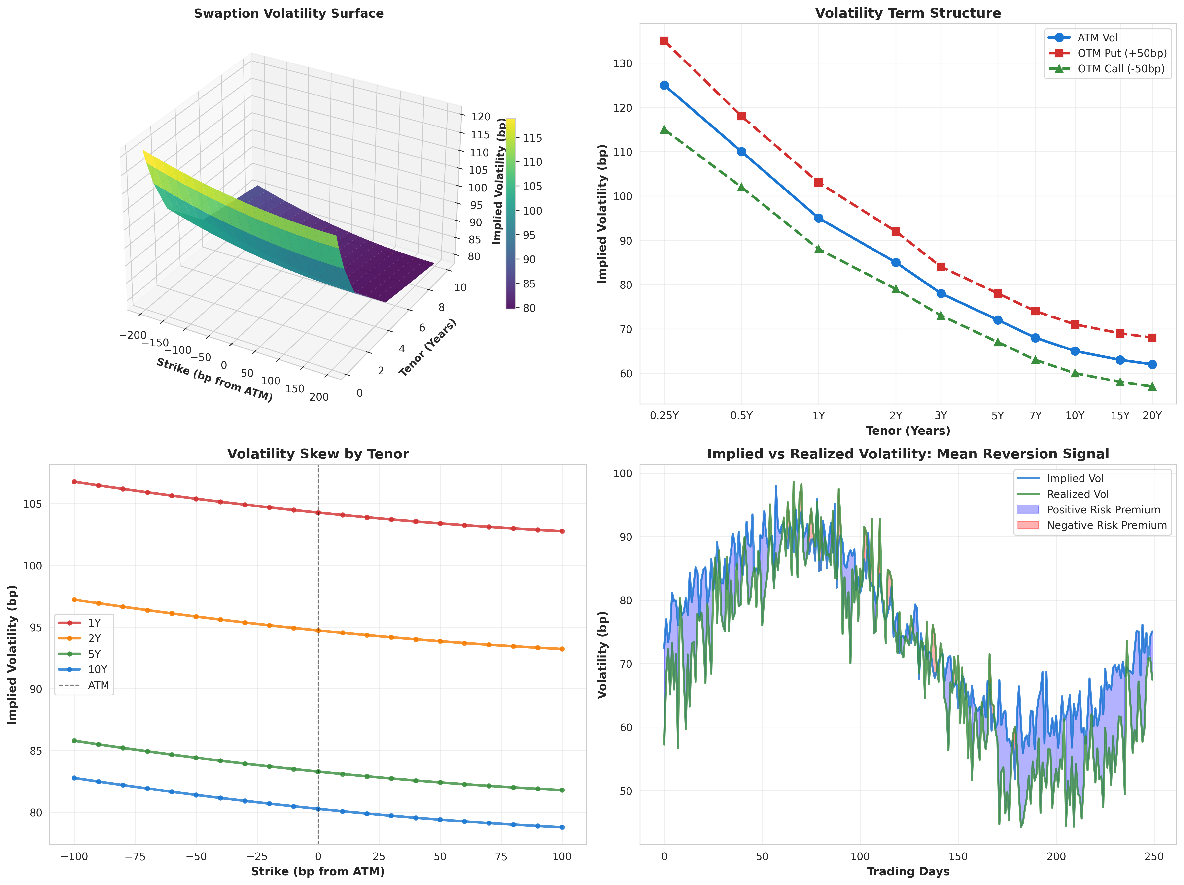

# Conclusion

This quantitative framework integrates regime detection, custom curve fitting, enhanced basis analytics, and comprehensive risk frameworks to provide systematic Treasury RV strategies. The methodologies extend significantly beyond standard tools, incorporating CTD optionality, repo dynamics, vol-adjusted carry, and auction calendar effects.

All frameworks implemented in production-grade Python with extensive backtesting validation across multiple market regimes including March 2020 COVID crisis and March 2023 regional banking stress.

_______________

*Comprehensive research framework for institutional fixed income trading operations.*